Lauryn Fowler M.D.
Military Chief Resident
Wright State University Boonshoft School of Medicine
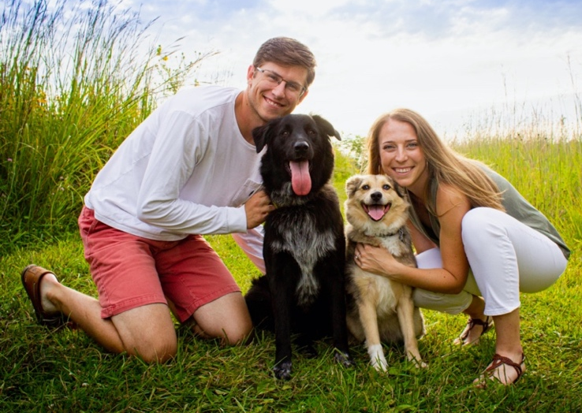
Hometown: Dayton, OH
Career Goal: Military career general pediatrician
One word to describe this residency: Growing

What do you like best about this program? Everyone including attendings are so nice and personable (we text with a majority of the attendings!). Such a good variety of medicine

What else would you like candidates to know about you, Dayton OH, or this residency? while these years have been challenging and the workload at times can be a lot I feel like I left these 3 years more than prepared for life after residency

Darah Yuhas M.D.
Civilian Chief Resident
Lewis Katz School of Medicine at Temple University
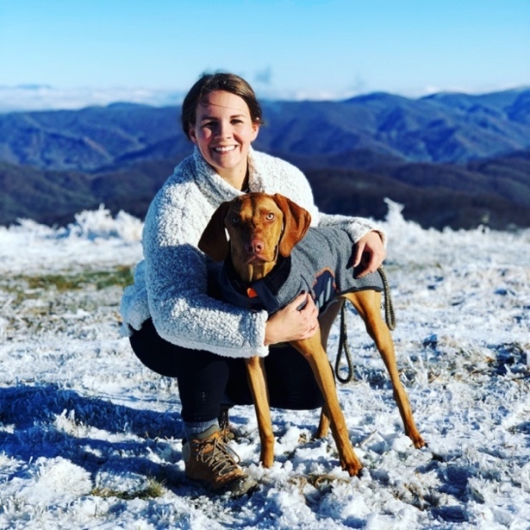
Hometown: Tallahassee, FL
Career Goal: Neonatology
One word to describe this residency: Family

What are your hobbies? Hiking with our dogs, disc golf, Orange Theory or any work outs with my friends!

What else would you like candidates to know about you, Dayton OH, or this residency? Dayton is a little treasure! Having never lived in the Midwest, I didn’t know what to expect but over the past 3+ years this city has truly turned into my home! I can’t imagine myself anywhere else.

Austin Beam M.D. – PGY3
University of Toledo College of Medicine
Hometown: Waynesville, OH
Career Goal: Hospital Medicine
One word to describe this residency: Inclusive

What do you like about Dayton? I like that Dayton is a very affordable place to live with great diversity. You can live downtown if you want a small city vibe or there are several surrounding suburbs within a short distance that are excellent for starting a family

What do you like best about this program? How helpful everyone is. Whether it be co-residents, staff or program leadership, everyone is willing to go above and beyond to help in anyway possible. It truly is a family atmosphere here at Dayton Children’s

Roma Chokshi, M.D. – PGY3
Northeast Ohio Medical University
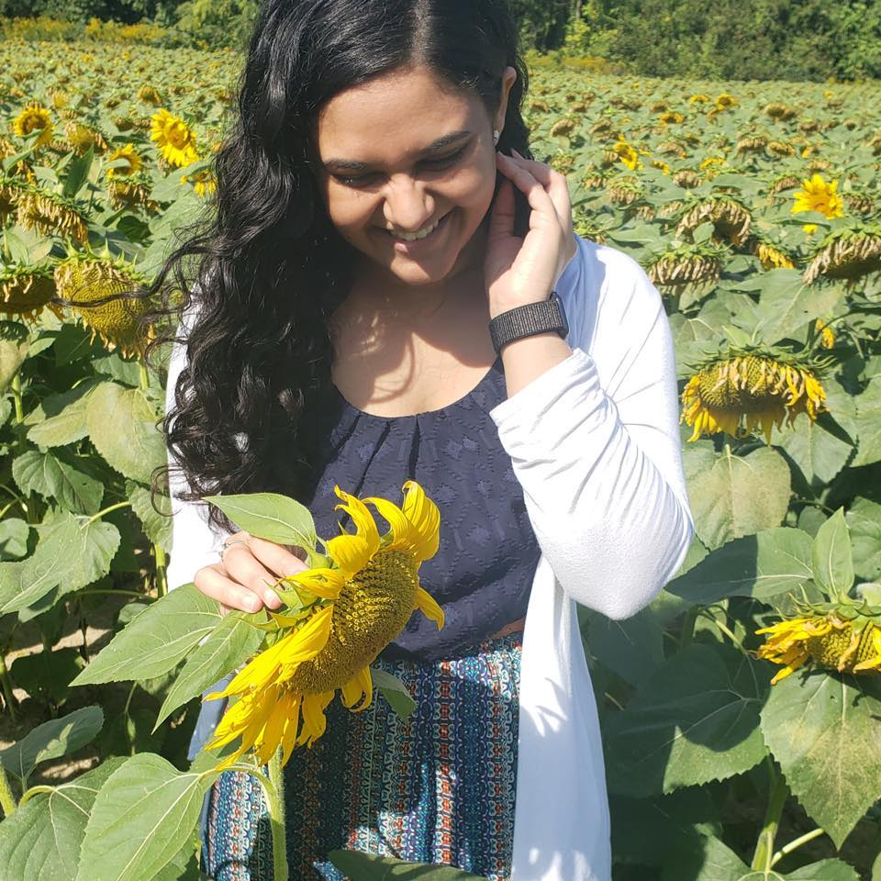
Hometown: Springfield, OH.
Career Goal: General pediatrics
One word to describe this residency: Family

What are your hobbies? I love to read, binge watch Netflix, and hang out with family/friends

What else would you like candidates to know about you, Dayton OH, or this residency? The residency program is one of the best for outpatient practice because of its focus on continuity of care. There is very few programs from my interview trail that allowed residents to be listed as PCP!

Lauren Clark, M.D. – PGY3
University of South Carolina School of Medicine - Greenville
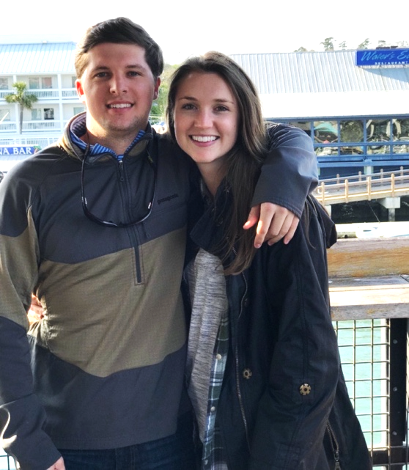
Hometown: Charleston, SC
Career Goal: Hospital Medicine or outpatient general pediatrics at an academic center
One word to describe this residency: Stellar - one word is hard, people.

What do you like about Dayton OH? The metro parks are pretty sweet, especially for taking our two dogs out and about. Being from the coast of South Carolina, I was hesitant about the winters and not being near the water anymore, but Dayton has been a pleasant surprise on both fronts. It gets comfortably cold without a harsh amount of snow (Now watch us have a record breaking winter - I’m not superstitious but I’m a little ‘stitious). As far as the water goes - there’s lakes to take the dogs swimming, rivers we have kayaked down, and paddle boarding.

What else would you like candidates to know about you, Dayton OH, or this residency? Even on the roughest of days, people leave still loving this residency and what we get the chance to do every day and I think that speaks volumes to this program. I also want to point out that we have a great support squad here. On a heavy note, people have been through some really rough times with unexpected changes in life that have occurred and it has been phenomenal to watch everyone have each other’s backs. It’s that kind of gang here in Dayton.

Amanda Cook D.O – PGY3
University of Arizona College of Medicine
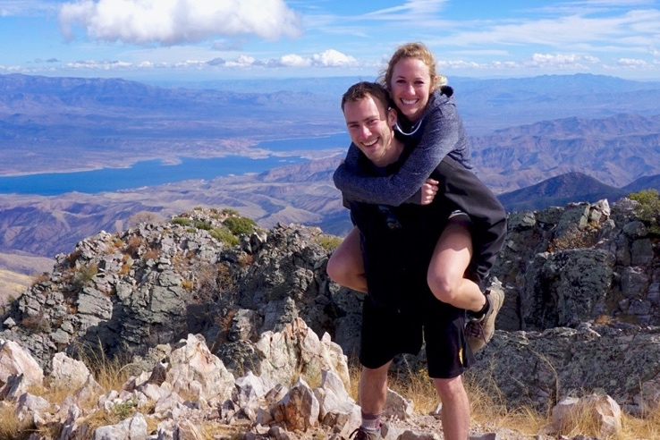
Hometown: Des Moines, IA
Career Goal: Outpatient pediatrics
One word to describe this residency: Teamwork

What attracted you to this residency/program?
Beautiful stand-alone children’s hospital, the residents support each other and go out of their way to help each other, friendly environment.

What else would you like candidates to know about you, Dayton OH, or this residency?
It’s easy to find outdoor adventures in the area! Our program has a lot of gatherings outside of work so it is easy to make friends and have fun. We also get a lot of opportunities to interact with each other throughout the day, which brightens up the busy, long days!

Rhiannon Flowers, D.O. – PGY3
Lincoln Memorial DeBusk COM
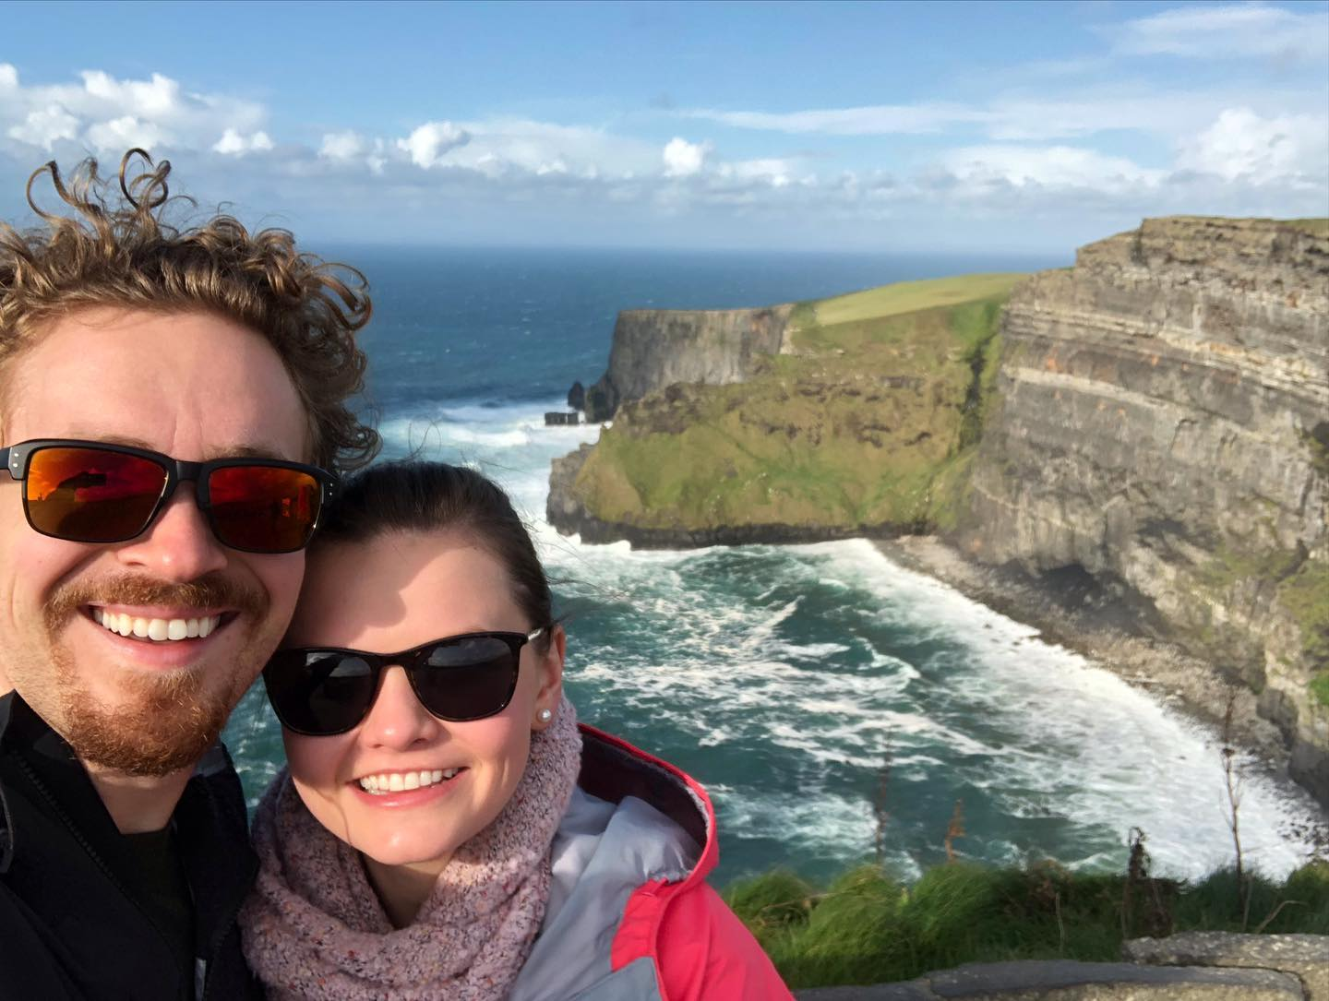
Hometown: Alexandria, VA
Career Goal: general pediatrics in an academic setting
One word to describe this residency: Supportive
What do you like about Dayton OH? There are always amazing outdoor activities available (hiking, biking, nature walks, kayaking, etc). There is an area for everyone (suburbs with single family homes to downtown lofts all within reasonable driving distance to the hospital).

What else would you like candidates to know about you, Dayton OH, or this residency? It is a great place and program to have the best of everything: raise a family, advance in your career goals/education, and maintain your mental health (with fun extracurricular activities).

Elizabeth Gawrys-Strand, M.D. – PGY3
Indiana University School of Medicine
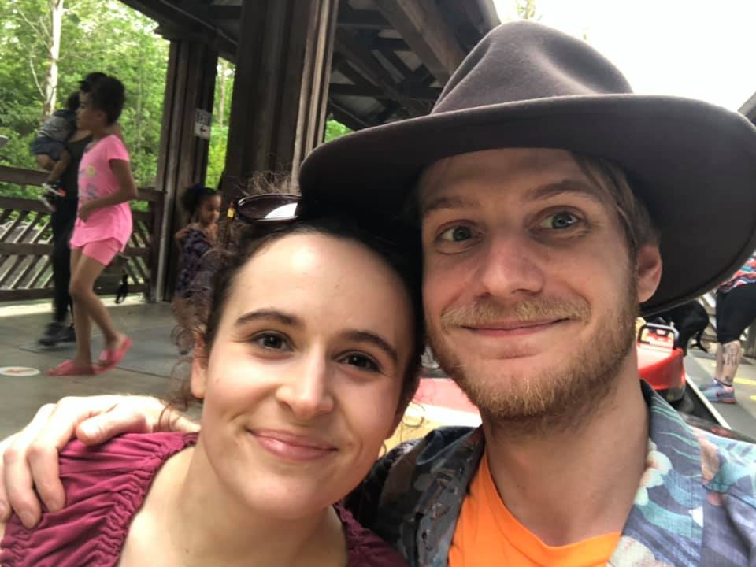
Hometown: Indianapolis, IN.
Career Goal: Primary care pediatrics in the Dayton area, likely fellowship in Developmental Pediatrics down the road
One word to describe this residency: Team

What are your hobbies? Watching Mystery Science Theater 3000 with my fiancé, watching anime (with or without my fiancé), hiking, reading about theology, making margaritas, and enjoying good food with friends

What do you like best about this program? Our program directors genuinely care about us and advocate for us, and the residents support each other.

Michael Prendergast M.D. – PGY3
University of Alabama School of Medicine
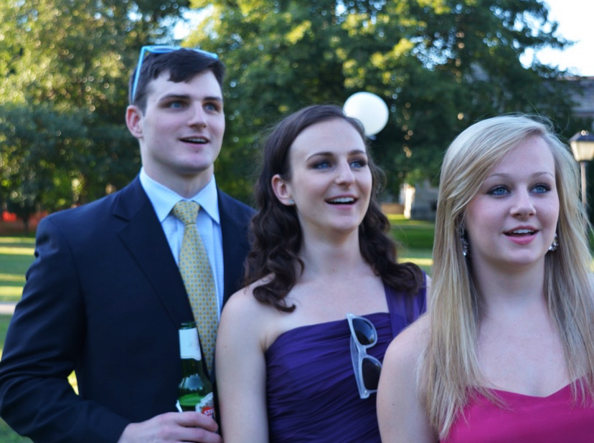
Hometown: Vestavia Hills, Alabama
Career Goal: ED fellowship
One word to describe this residency: CHILLdren

What are your hobbies? biking, travel, making brunch, racquetball, Cleveland sports, grilling

What do you like best about this program? everyone (including attendings) is as personable and friendly as they are knowledgeable (very!). I look forward to going into work each day because I can’t wait to see all my friends. Also, you learn a lot.

Alec Kelley, M.D. – PGY3
Indiana University School of Medicine
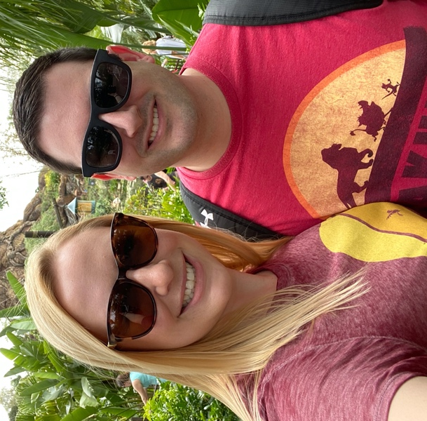
Hometown: Evansville, IN
Career Goal: Outpatient pediatrics
One word to describe this residency: Supportive

What are your hobbies? Video games, hiking, trying different beers and whiskies, learning more about gourmet coffee
What else would you like candidates to know about you, Dayton OH, or this residency? Best attendings that I have worked with at any institution

Samantha Neumeier M.D. – PGY3
Northeast Ohio Medical University
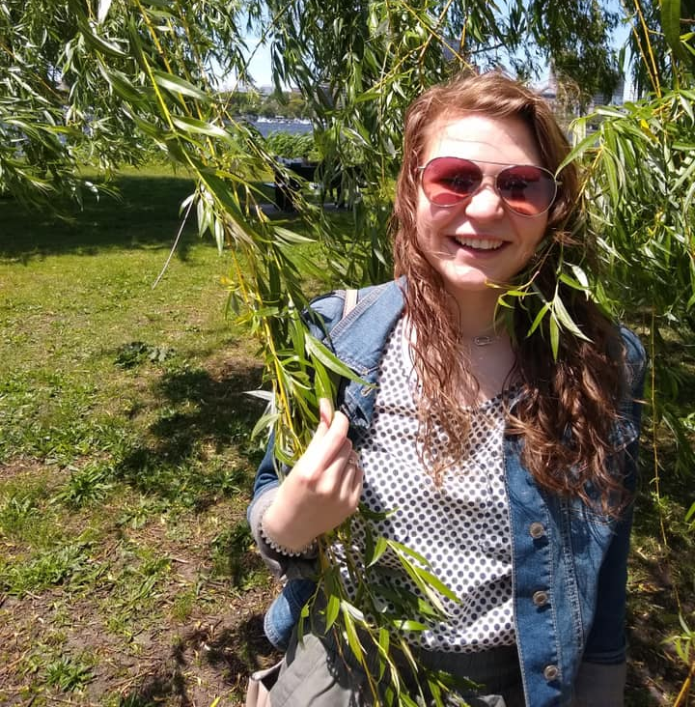
Hometown: Troy, OH.
Career Goal: Hospital Medicine
One word to describe this residency: Supportive

What attracted you to this residency/program? Location, medium sized, family atmosphere, no fellows, my own continuity patients and full day clinic

What do you like best about this program? Everyone is very supportive of each other

Toni Stevenson M.D. – PGY3
Medical University of South Carolina
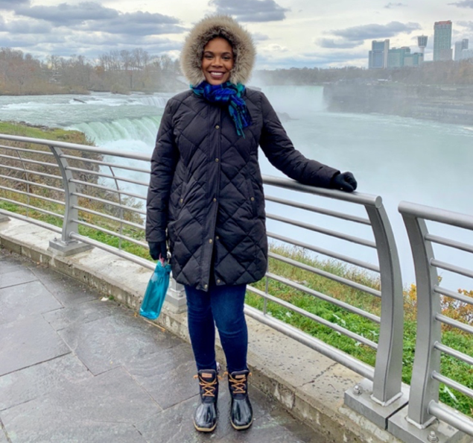
Hometown: North Augusta, Georgia
Career Goal: Travel the world as an Air Force pediatrician
One word to describe this residency: Memorable

What are your hobbies? Hiking, cooking, traveling

What do you like best about this program? Spending time with co-residents and making awesome memories

Rachel McCoy, M.D. – PGY3
Northeast Ohio Medical University
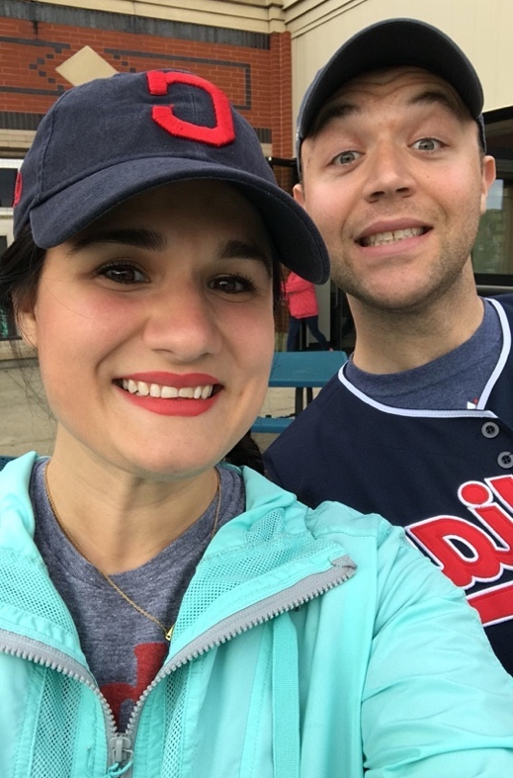
Hometown: Medina, OH
Career Goal: Hospital Medicine or Heme/Onc fellowship!
One word to describe this residency: Nurturing
What are your hobbies? I love live theatre, Orangetheory classes, and my book club! My goal this year is to read 100 books, and I'm currently at 56!

What do you like best about this program? I LOVE my co-residents, having the opportunity to have my own patients in our full-day continuity clinic, and being able to experience a different patient population on the air force base. I love that the faculty members really know me, especially the military attendings, which is awesome as I'm one of the civilian residents.

Chelsea Tyson M.D. – PGY3
University of Arkansas for Medical Sciences COM
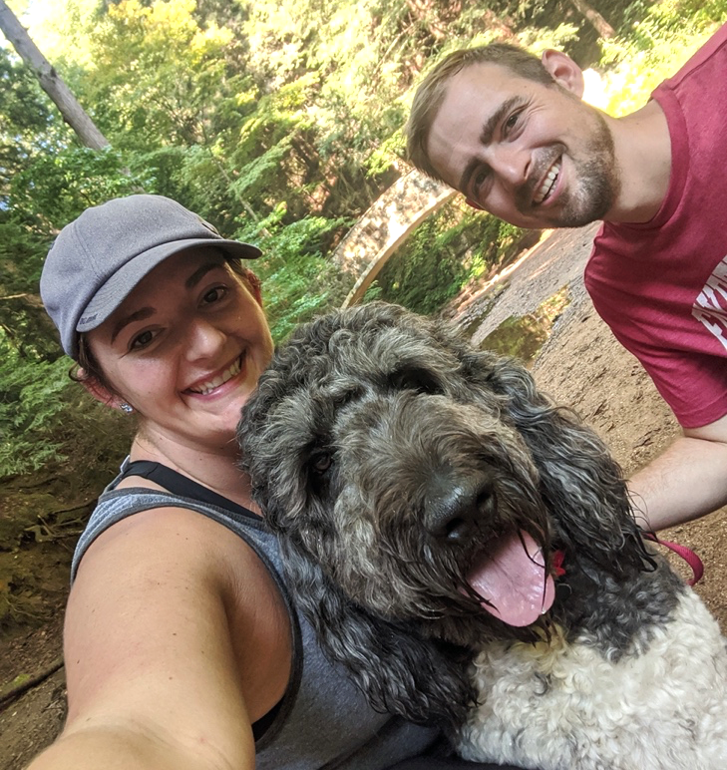
Hometown: Little Rock, AR
Career Goal: We'll see!
One word to describe this residency: Approachable

What are your hobbies? Gardening, running, eating, traveling

What do you like best about this program? My co- residents are the best human beings alive and are incredibly supportive

Drew Towles D.O – PGY3
Des Moines University COM
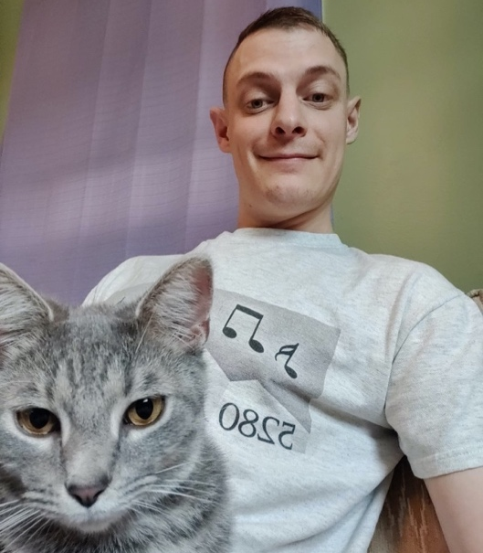
Hometown: Berthoud, CO.
Career Goal: Outpatient pediatrics or flight medicine
One word to describe this residency: Home

What attracted you to this residency/program? It is a free-standing Children's hospital with high volume along with good leadership

What do you like about Dayton OH? Good brewery choices. You can become pretty involved in the community, especially by supporting small business, and then you find out about local places that have a lot of character to offer. Easy to chat with people and make new, non-medical friends.

Maggie Seis D.O. – PGY3
Des Moines University COM
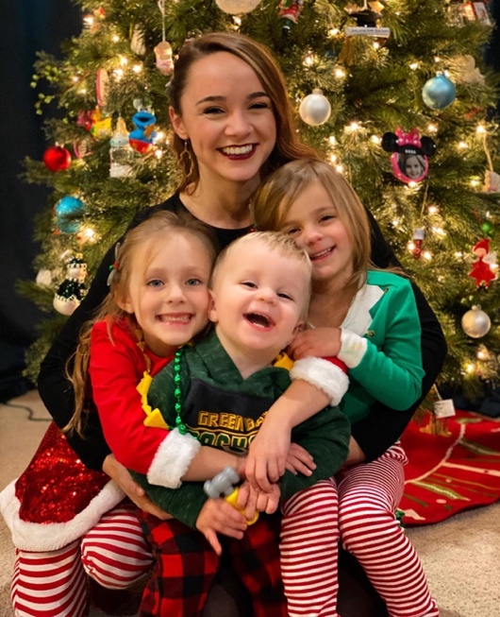
Hometown: Appleton, WI
Career Goal: General Pediatrics with newborn nursery
One word to describe this residency: family

What attracted you to this residency/program? the volume and acuity of patients, lack of fellowships (more 1:1 time with attendings), the people, the balance between lecture education and hands-on learning

What do you like about Dayton OH? There are a lot of parks/outdoor activities to explore, Cincinnati/Columbus are nearby for big events and easy travel, not too large of a city, reasonable cost of living, and friendly Midwest people

Yejin Yoo M.D. – PGY3
F. Edward Hébert School of Medicine, Uniformed Services University of the Health Sciences
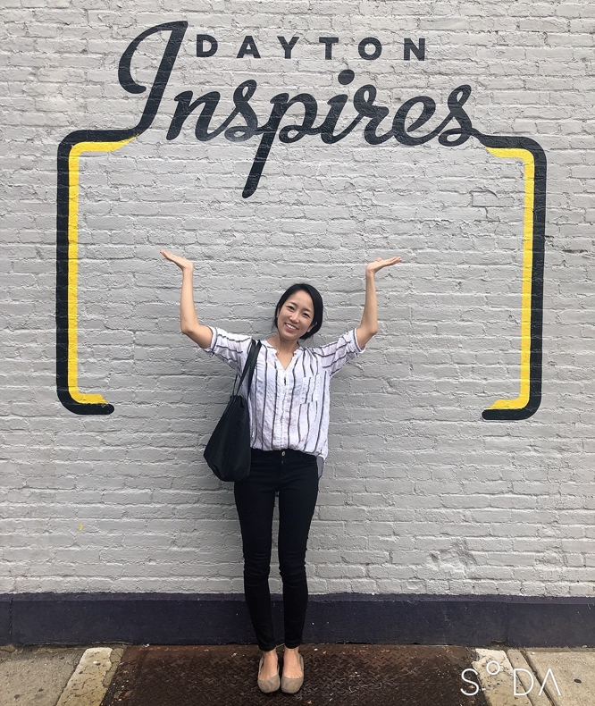
Hometown: Los Angeles, CA
Career Goal: Heme/Onc fellowship
One word to describe this residency: Family

What are your hobbies? growing plant babies, shopping, social media

What do you like best about this program? supportive staff including nurses/RTs; perfect sized hospital with plenty of patient volume

Raegan Austin D.O. – PGY2
New York Institute of Technology COM
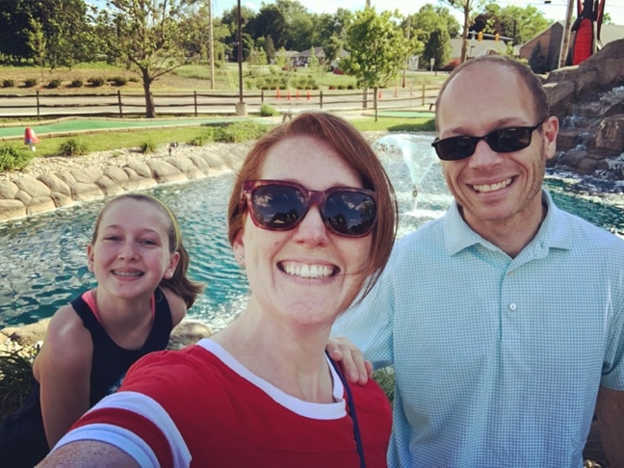
Hometown: Saratoga Springs, N.Y.
Career Goal: General Pediatrics, hopefully stay in Dayton!
One word to describe this residency: Family

What do you like about Dayton OH? The city takes pride in its metro parks. Gorgeous murals around town show how highly they value the arts. Everything we need is right here between Columbus and Cincinnati. It is the perfect mix of my hometown of Saratoga Springs, NY and my husband’s hometown of Wayne, MI. All four seasons with great people and great food! Be sure to see Dorothy Lane Market and Warped Wing Brewery.

What do you like best about this program? Co-residents, attendings, specialists - everyone is cheering you on! Whether you’ve nailed it or fell on your face, you can always find a high-five or a hug in the residents‘ lounge.

Kate Boroff, M.D. – PGY2
Wright State University Boonshoft School of Medicine
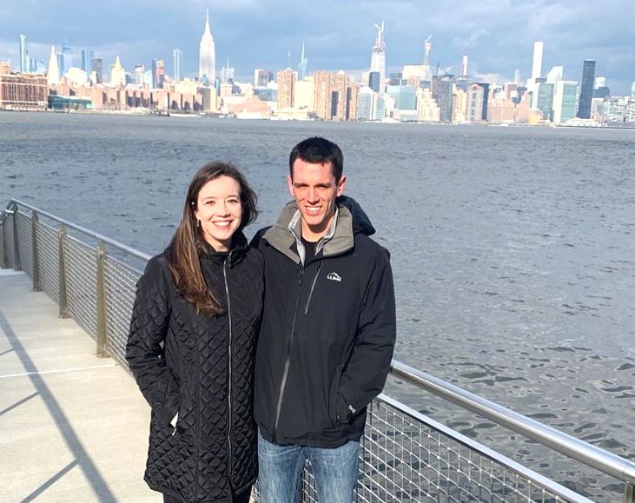

Hometown: Lucas, OH
Career Goal: Hospital Medicine or outpatient pediatrics (but haven’t ruled out subspeciality!)
One word to describe this residency: FANTASTIC

What attracted you to this residency/program? I had a lot of rotations here as a medical student and loved all of them! The residents, attendings, nurses, and other staff were incredibly nice to work with. I also love the atmosphere of the hospital. There are so many new additions, everything is colorful, and there are windows everywhere which makes it a great work environment.

What do you like about Dayton OH? Living in Dayton is awesome because you get most of the things a big city offers without the negatives of a big city (traffic, no downtown parking, no green space).I love going to musicals or performances at the Schuster Center. There are lots of amazing local restaurants. My husband and I really enjoy outdoor activities and there are so many different activities including hiking, kayaking, disc golf, sand volleyball, etc.

Rachel Carlson, D.O. – PGY2
Michigan State University COM

Hometown: Grand Rapids, MI
Career Goal: General Pediatrics
One word to describe this residency: Encouraging

What do you like about Dayton OH? Smaller city, lots of parks, Miami Valley bike trails, low cost of living

What do you like best about this program? How invested everyone you work with is in your learning

Caleb Botta, M.D. – PGY2
Medical College of Georgia
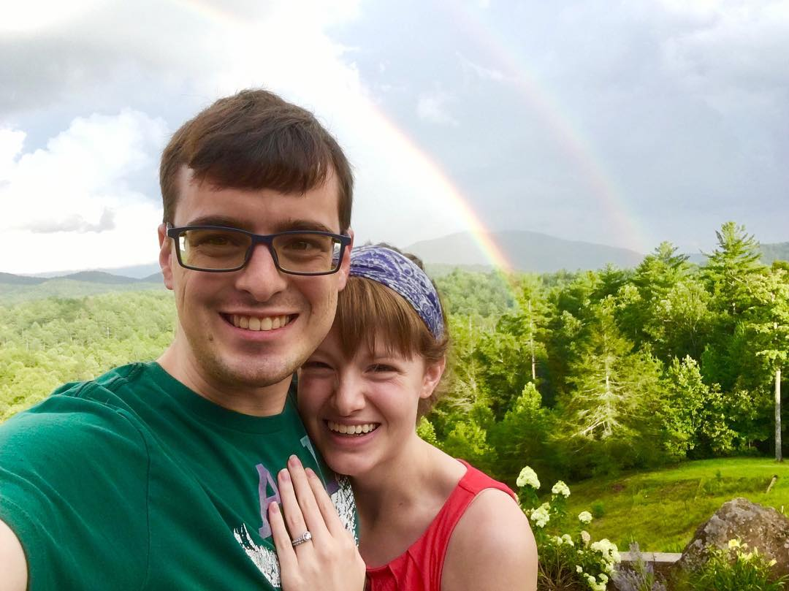
Hometown: Atlanta, GA
Career Goal: Outpatient pediatrics
One word to describe this residency: Awesome

What are your hobbies? Guitar, playing with my dog

What else would you like candidates to know about you, Dayton OH, or this residency? Kind people, family friendly culture, committed to making you excellent

Catie Bernal D.O. – PGY2
Texas College of Osteopathic Medicine
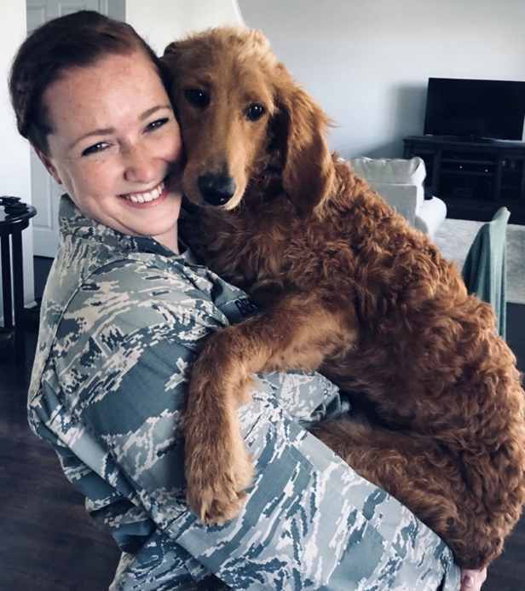
Hometown: Plano, TX
Career Goal: Endocrinology
One word to describe this residency: Family
What do you like best about this program? Everyone in the program is so supportive. Everyone was open and honest about what they were going through and how they were feeling. The residents help each other through the struggle of residency.

What are your hobbies? Cooking, crafting, gardening, playing with my puppies : )

Katherine Neltner, M.D. – PGY2
University of Louisville School of Medicine
Hometown: Alexandria, KY
Career Goal: Outpatient pediatrics
One word to describe this residency: Family

What are your hobbies? Beekeeping, puzzle solving, theatre, playing violin, reading, crochet!

What attracted you to the program? I loved how both personable and dedicated the faculty are to their patients as well as the residents, the all star program directors, the close-knit community feel of the program, the wide patient acuity, the rigorous curriculum, and the beautiful facilities!

Preston Keiffer, M.D. – PGY2
Robert Wood Johnson Medical School at Rutgers Univ
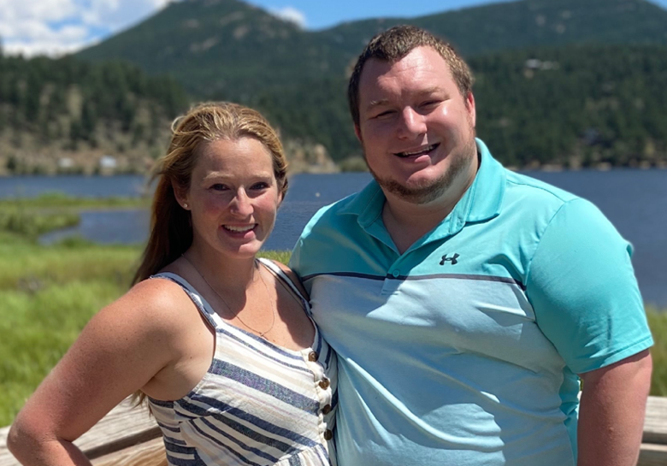
Hometown: Voorhees, NJ.
Career Goal: General Pediatrics
One word to describe this residency: is "Chick-fil-A" one word?

What do you like about Dayton OH? The Dayton area (Centerville specifically where my wife and I live) is amazing with many fun spots for food, drinks, entertainment, hiking, sports, etc. The people in general are so nice (way nicer than New Jersey people)!

What do you like best about this program? I have not met a single attending across all specialties and all hours of day or night that was not open to questions, teaching or a consult. I really appreciate the learning environment and camaraderie in this program both on WPAFB and at DCH!

Spencer Hart M.D. – PGY2
University Michigan Medical School
Hometown: Rexburg, ID
Career Goal: General pediatrics
One word to describe this residency: Supportive

What do you like best about this program? Just the right number of residents; not too big that you get lost in the crowd or so small that you don't have any variety in who you work with. No fellows thinning opportunities for procedures. Also, great family friendly area.

What are your hobbies? Spending time with my kids on bike rides and at parks

Courtney Pierron D.O. – PGY2
Ohio University Heritage COM
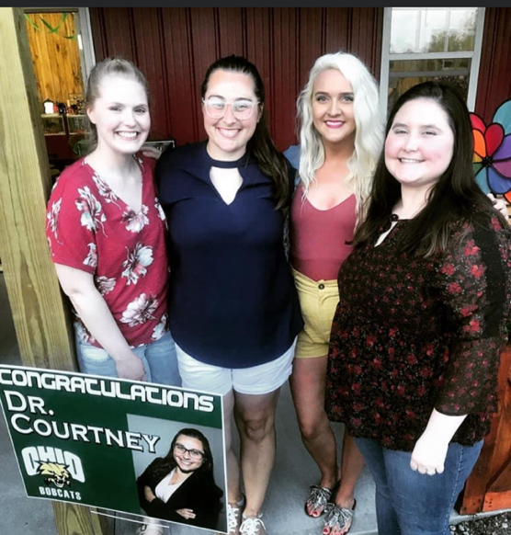
Hometown: Portsmouth, OH
Career Goal: Undecided! Probably a subspeciality
One word to describe this residency: Great

What attracted you to this residency/program? The people, integration of military and civilian residents, and the program directors (Dr. Burke and Dr. Kiger)!

What do you like best about this program? Exposure to a variety of different pathology, no fellows and great amount of vacation time compared to other places

Daniel Oder, D.O. – PGY2
Ohio University Heritage COM
Hometown: Youngstown OH
Career Goal: Hem/Onc, Cardiology, unsure which one yet
One word to describe the residency: Teamwork

What attracted you to this residency/program? I had a great experience during a sub-I rotation in the PICU. I really liked how everyone worked together as a team and the time they took to teach me new things

What are your hobbies? dancing, hiking, playing my keyboard, cheering on the buckeyes O-H!!, going to music festivals

Mitchell McClellan D.O. – PGY2
Lake Erie COM – Bradenton
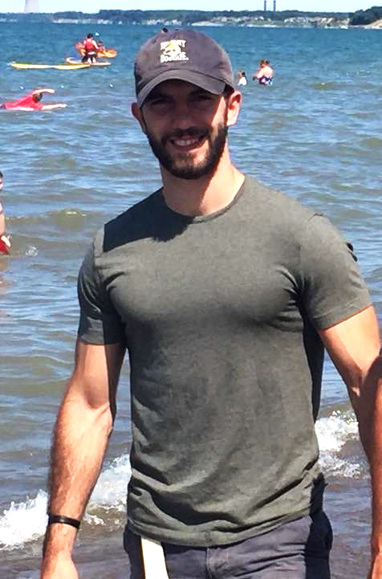
Hometown: Cincinnati, OH.
Career Goal: General pediatrics
One word to describe this residency: Family

What are your hobbies? Lifting, hiking, violin, rock climbing, soccer

What else would you like candidates to know about you, Dayton OH, or this residency? The positive, safe learning environment makes each day exciting. Attendings encourage learning and welcome all questions.

Matthew Rasch D.O. – PGY2
Ohio University Heritage COM
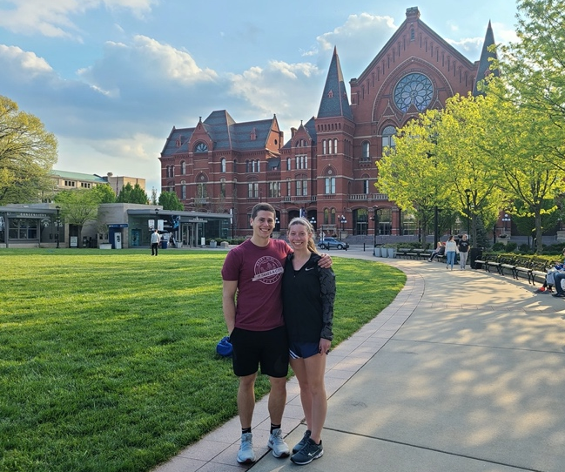

Hometown: Bellbrook, OH
Career Goal: General pediatrics
One word to describe this residency: Challenging

What do you like best about this program? You can count on everyone here to have your back, co-residents challenge each other to be better

What else would you like candidates to know about you, Dayton OH, or this residency? DCH is a perfect size, there is a lot of diversity in the people of Dayton, the combination of military and civilian is unique and cool, the residents here are smart and supportive

Michelle Towers M.D. – PGY2
F. Edward Hébert School of Medicine, Uniformed Services University of the Health Sciences

Dillon Stanfield M.D. – PGY2
University of Louisville School of Medicine
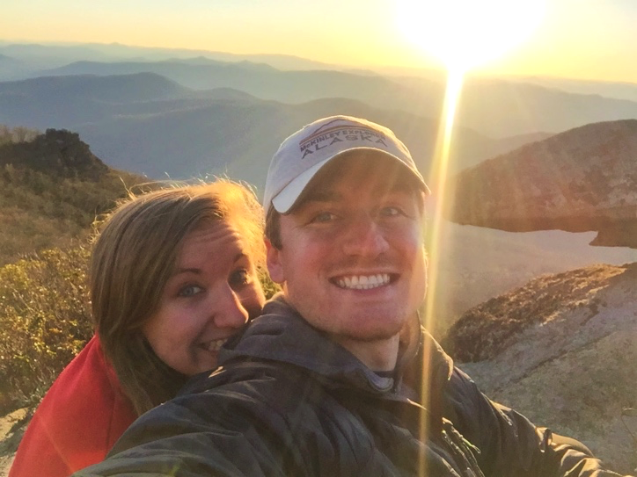
Hometown: Cincinnati, OH
Career Goal: General Pediatrics or NICU
One word to describe this residency: Dynamic

What do you like best about this program? There is such great camaraderie between residents and I feel like I can consistently rely on others on busy days or in tough situations. I also appreciate the autonomy I have been allowed as an upper level!

What else would you like candidates to know about you, Dayton OH, or this residency? While almost all pediatric residencies, including ours, expose you to impoverished communities and the impact of social determinates of health on childcare, rotations at WPAFB provides a nice juxtaposition and perspective into more stable social situations. I believe this comparison helps show both the impact of socioeconomics on childcare and also a more stable patient population that many residents are not exposed to in continuity clinic.

Caitlin Way D.O. – PGY2
Oklahoma State University COM
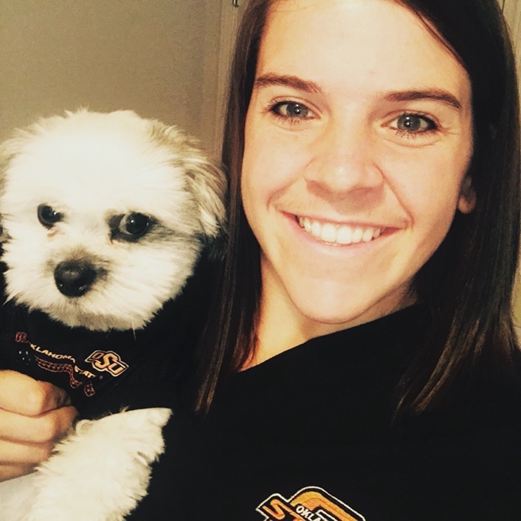
Hometown: Mitchell, SD
Career Goal: I’m considering PICU, but I’m undecided!
One word to describe this residency: Abundant

What attracted you to this residency/program? High acuity and patient volume but still a smaller program size with a tight-knit resident culture. There are also several people who have attained prestigious fellowship opportunities showing this program prepares you well and makes you a marketable candidate to pursue those endeavors.

What do you like best about this program? I really really enjoy my co-residents. Not just in my class (which is pretty top notch) but even the seniors. There is good camaraderie within every group I’ve worked with and seniors take pride in mentoring and helping more junior residents. There are also several people that really truly enjoy and get excited about medicine, which is something that I found rare in some other pediatric residency programs.

Michael Wright D.O. – PGY2
Ohio University Heritage COM
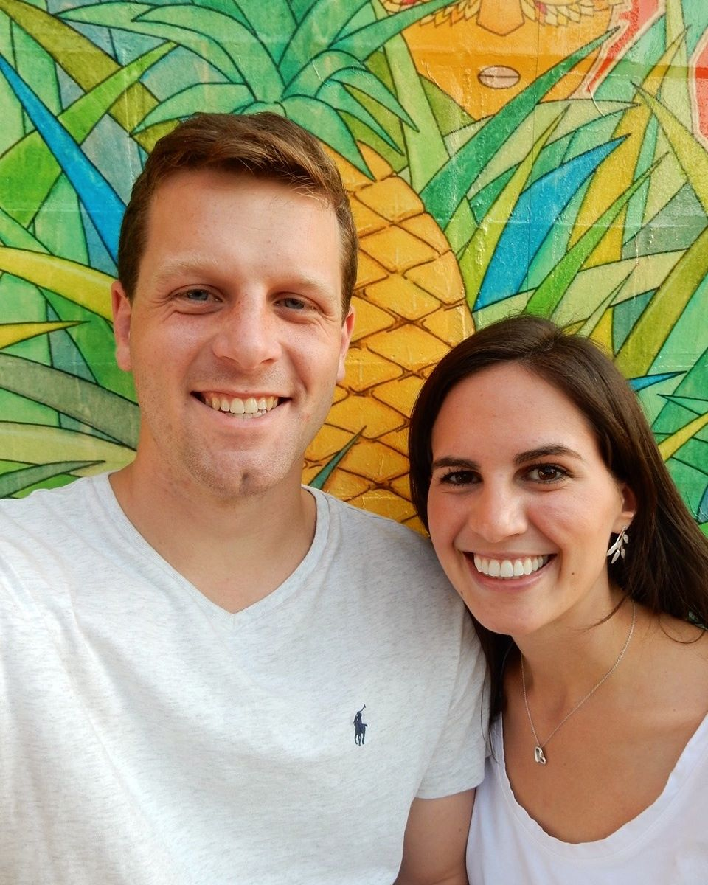
Hometown: Cincinnati, OH.
Career Goal: Adolescent medicine or general pediatrics
One word to describe this residency: Supportive

What attracted you to this residency/program? location, wonderful people, independence of senior residents, robust educational opportunities.

What do you like about Dayton OH? my beloved Dayton Flyers, the Dragons, Oregon district, Eudora brewery

Elizabeth Albuquerque M.D – PGY1
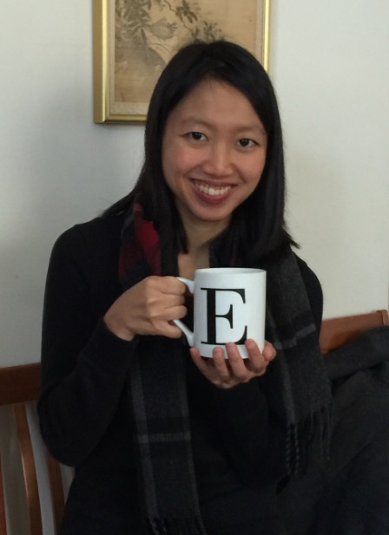
West Virginia University SOM

Hometown: Morgantown, WV
Career Goal: General pediatrics
One word to describe our program: Supportive!

What do you like most about our program? As someone interested in general pediatrics, I was attracted to the program's focus on a well-rounded pediatric education. The size of the program was not too big or small. Having full-day continuity clinic was also a big draw for me! Despite my interview being virtual last year, the residents and faculty genuinely wanted to get to know me and were open to answering any questions I had about the program. Their sincere attitudes gave me confidence in the support that I would receive.

What do you like about Dayton? The people living here are kind and willing to help you! In addition, Dayton has all the things you could have in a city. Downtown has many cultural activities, and the MetroParks and surrounding suburbs are nice escapes. There are many great food and drink options here as well. I'm a big fan of 2nd Street Market and Dorothy Lane Market. You can find me getting coffee at Press or Ghostlight. If you want to explore larger cities, Columbus and Cincinnati are an hour away each.

Eric Baughman D.O – PGY1
Ohio University Heritage COM

Hometown: Springboro, OH
Career Goal: Undecided
One word to describe our program: Friendly
What do you like most about our program? I really like the size of our residency program and the size of the hospital overall. We all know each other and we know all the attendings we get to work with. It makes for a much better learning environment when people know who you are.

What do you like about Dayton? My family is close by. I also like being near Columbus and Cincinnati. There’s also a lot of outdoors stuff to do around town!

Maeve Elliot M.D. – PGY1
University of Colorado School of Medicine
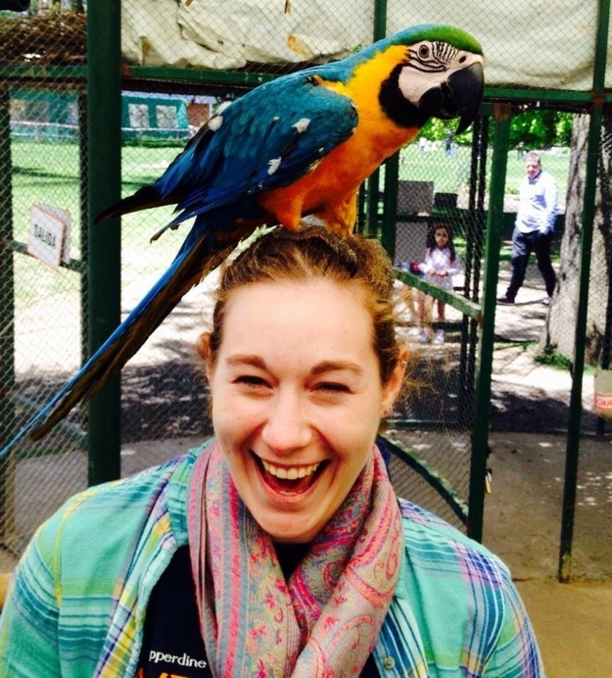

Hometown: Highlands Ranch, CO
Career Goal: Generalist (not sure if hospital Medicine, ER, or general peds)
One word to describe our program: Welcoming

What do you like most about our program? I was definitely drawn in by how friendly and welcoming everyone was. I felt like people genuinely wanted to get to know me and cared about me.

What are your hobbies? I enjoy swimming, Netflixing, sleeping, cuddling my cats, and just plain laughing and having fun!

Marcus Erdman M.D. – PGY1
Penn State College of Medicine
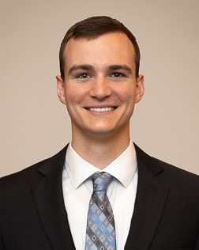

Hometown: Erie, PA
Career Goal: undecided!
One word to describe our program: Snacks

What do you like most about our program? I love the opportunity to care for diverse patient populations through rotations at both the Dayton Children’s and Wright-Patterson Air Force Base. Also, DCH is absolutely BEAUTIFUL and has the CUTEST therapy dogs.

What are your hobbies? My hobbies include running half marathons slowly, putting up Penn State decorations despite being in Ohio State territory, singing out of key, eating free food, and hitting horrible golf shots

Nathan Fister D.O. – PGY1
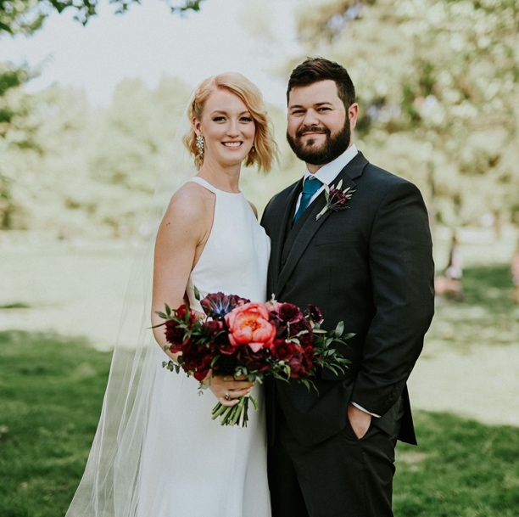
Ohio University Heritage COM

Hometown: Columbus, OH
Career Goal: Undecided
One word to describe our program: Supportive

What do you like most about our program? It’s an incredibly supportive learning environment.

What do you like about Dayton? Lots of great breweries

Emma Friedl D.O. – PGY1
Lincoln Memorial DeBusk COM
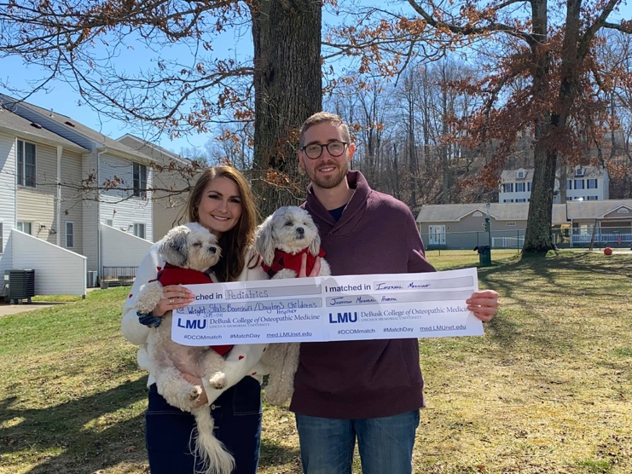
Hometown: Kenosha, WI
Career Goal: Pediatric Cardiology
One word to describe our program: Supportive

What do you like most about our program? A huge factor for me and something I asked every program was about the atmosphere. I was looking for teammates and mentors not competitors. I right away could tell the warm and supportive environment DCH had.

What do you like about Dayton? There’s tons of beautiful parks as well as plenty of restaurants (dog friendly) and fun ways to keep off days exciting!

Meghan Gartner M.D. – PGY1
University of Kentucky College of Medicine (cats by 90 😼💙)
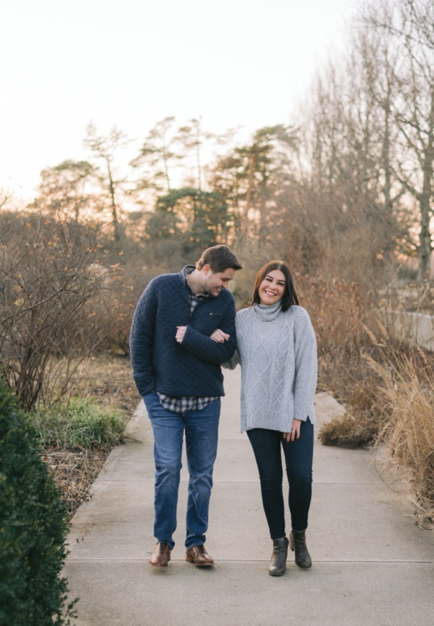

Hometown: Fairfield, OH
Career Goal: Outpatient Gen Peds vs. Adolescent vs. Child Abuse???!!!
One word to describe our program: fam

What do you like most about our program? DCH was everything I was looking for in a residency match! My ideal program was a smaller one in which residents were close-knit and considered each other family, but also gave us the opportunity to see and treat high acuity, high complexity patients. That is truly what you get here as a resident— 47 new besties and a LOT of experience!
What do you like about Dayton? I’m biased, but Ohio (and the Midwest in general) is a magical place to live. From our corn fields to our chili on spaghetti…. Haha. Kidding. But in all seriousness-- Dayton is an incredible hidden gem of a place. You get big city vibes with all the small town feels. There’s something for everyone here. Parks, coffee shops/breweries, big shopping complexes, you name it! Always cool stuff you can do when you’re off!

Paige Hampton D.O. – PGY1
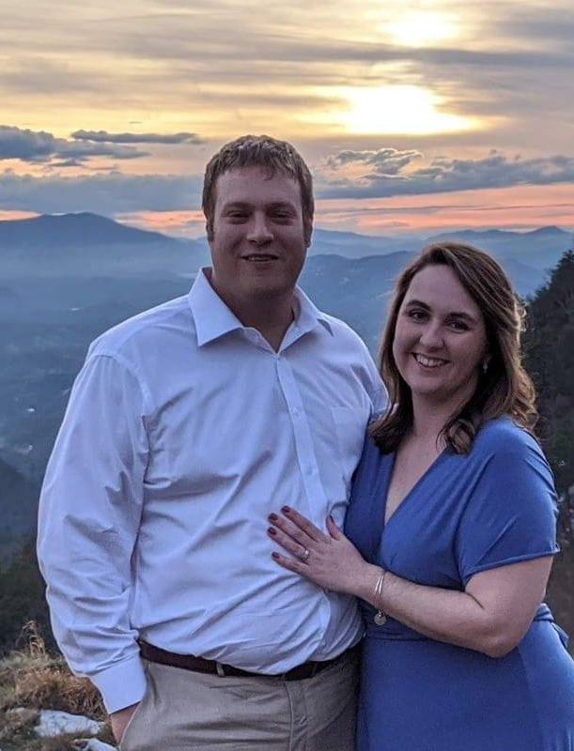
University of Pikeville Kentucky COM

Hometown: Henderson, Kentucky
Career Goal: Hospital Medicine (at the moment!)
One word to describe our program: Family
What do you like most about our program? Everyone is so friendly, lots of autonomy, and the program really promotes residents as teachers. Also, how can you not love Peppermint and Millie!

What are your hobbies? Sleeping, hanging out with my husband and friends, and exploring the local restaurants/breweries!

Jarom Jardine D.O. – PGY1
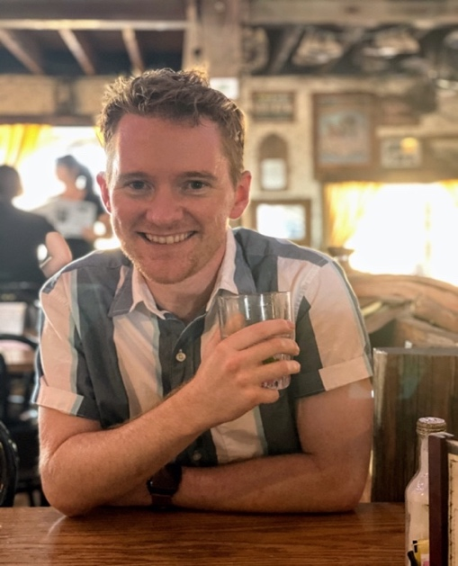
Kansas City University COM

Hometown: Idaho Falls, Idaho
Career Goal: Air Force Pediatrician
One word to describe our program: Team

What do you like about Dayton? Metro parks and bike paths that are all over make it a fun place to go outside. Downtown Dayton is also a lot of fun, they have several breweries that are cool to check out.

What are your hobbies? I like reading, rock climbing, hiking and camping

Nicole Mercier M.D. – PGY1
University of Arkansas for Medical Science COM
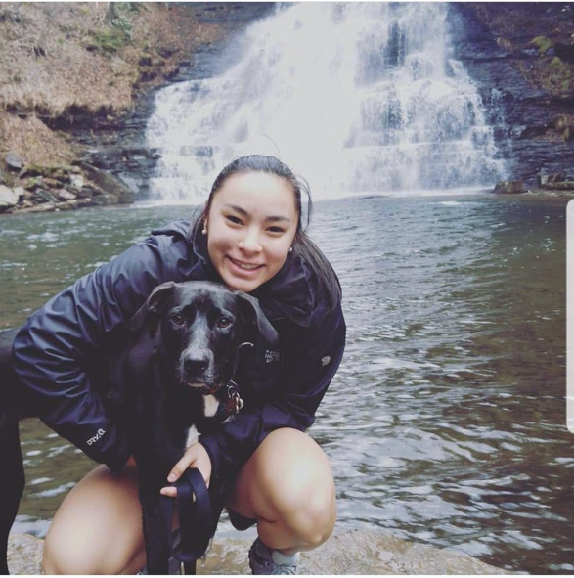

Hometown: Roanoke, VA
Career Goal: Gen Peds or NICU!
One word to describe our program: Supportive

What do you like most about our program? The people! When I rotated at DCH/WPAFB as a 4th-year medical student, everyone from the program directors to faculty and residents were so supportive of each other. In addition, I really enjoyed the size of DCH/WPAFB as well as the size of the residency class.

Alexis Mills M.D. – PGY1
University of Nebraska Medical Center COM
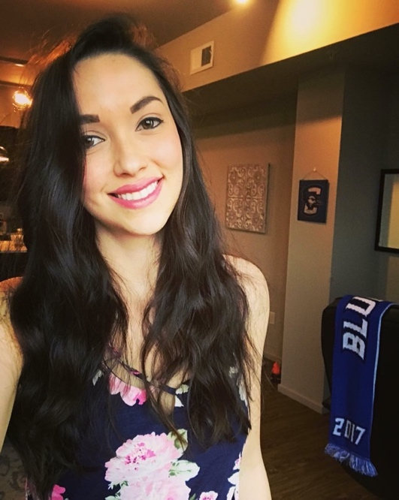

Hometown: Las Cruces, NM
Career Goal: I would like to continue to serve my country while becoming a general pediatrician or pediatric endocrinologist!
One word to describe our program: Welcoming

What do you like most about our program? I was attracted to this program by the fact that it is a combined Air Force and Civilian pediatric program that allows residents to experience working in many different settings as well as with many demographics and socioeconomic backgrounds.

What do you like about Dayton? It is a beautiful area, especially if you enjoy the outdoors. Also, great affordable housing and little to no traffic!

Shashank Mittal M.D. – PGY1
Texas Tech University Health Sciences Center SOM
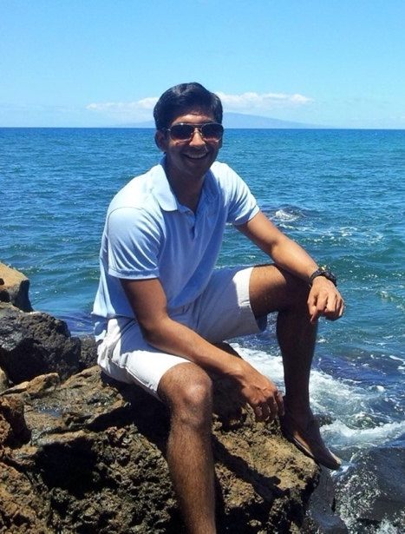

Hometown: Dallas and San Antonio, Texas
Career Goal: GI or Hospital Medicine
One word to describe our program: Friendly, supportive, warm

What do you like about Dayton? Dayton is a great medium-sized city that is very affordable. There are plenty of things to eat, drink, and do in the Dayton area. We are close to several larger cities if you ever have a need for that. Or if you are like me, there are lots of parks and natural areas you can escape to when you have time off.

What are your hobbies? I like board games, cars, billiards, and hiking.

Elizabeth Morrison D.O. – PGY1
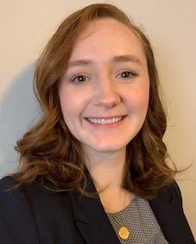
University of Pikeville Kentucky COM

Hometown: Crescent Springs, KY
Career Goal: Undecided - could see myself doing inpatient, outpatient, a mix of both, or adolescent medicine!

One word to describe our program: Supportive
What do you like most about our program? I love the diverse populations we serve! We are able to make a real difference for our patients, and our faculty supports us in providing the best care possible for these kids and helping us learn from these experiences so we can apply them to our practice. I knew the experiences I would have at Dayton Children's would help me become the best pediatrician I can be.

What do you like about Dayton? I love the variety of food options we have (especially for a city this size), the amount of outdoor space for hiking and kayaking, and the community here. There are many people invested in making Dayton a great place to live and building off our assets while also paying homage to our history, and that's exciting to be a part of. (P.S. Go Flyers!)

Zachary Ross D.O. – PGY1
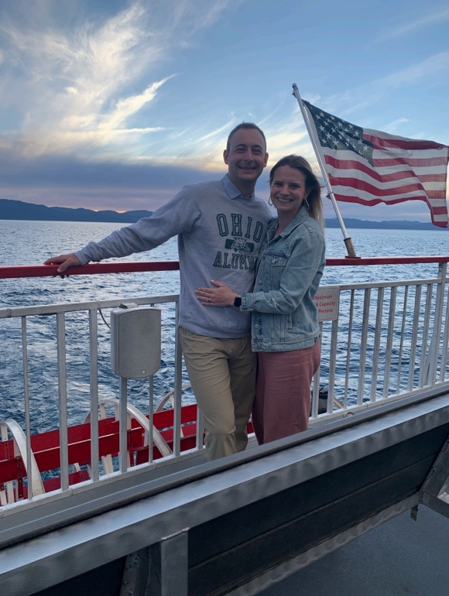
Ohio University Heritage COM

Hometown: Westerville, OH
Career Goal: Undecided
One word to describe our program: Supportive

What do you like most about our program? I loved the atmosphere and volume that this program provides. While I am unsure what my future plans in Pediatrics are I am certain that I will receive a well rounded experience here at Dayton Children’s. I also really enjoyed my month rotating with the program during my 4th year and felt like the resident did a great job of including me in activities/events outside the hospital.

What are your hobbies? I enjoy watching and playing sports. I am a huge Ohio State Football fan! I also enjoy hiking with my wife and our 5 year old lab shepherd mix Nala.

Renae Simons D.O. – PGY1
Campbell University School of Osteopathic Medicine
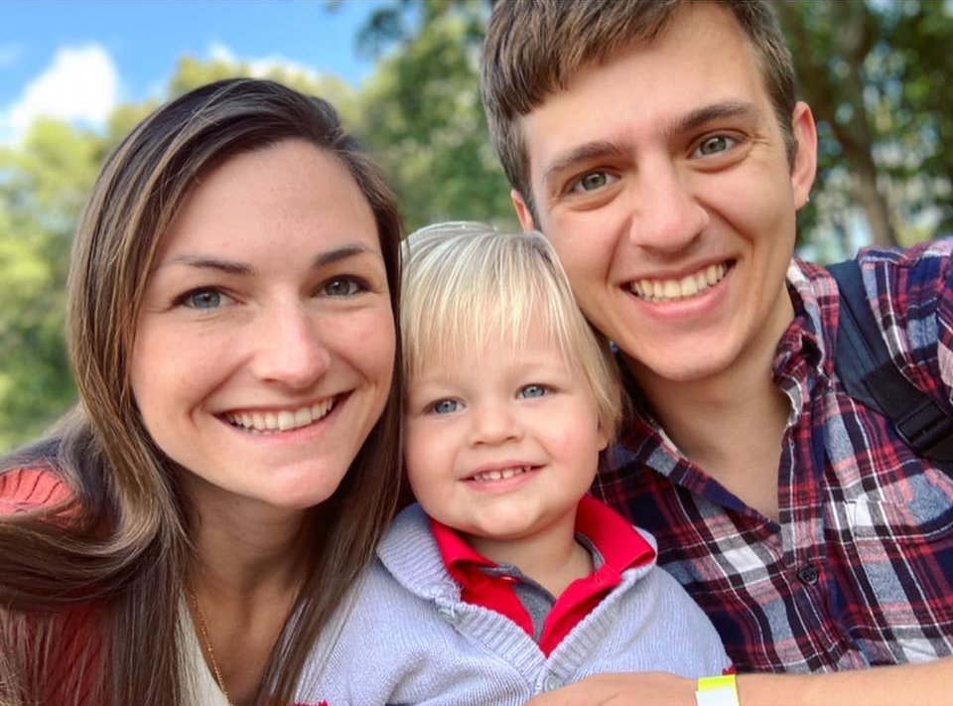
Hometown: Mount Vernon, OH
Career Goal: Pediatric Hematology/Oncology
One word to describe our program: Family

What do you like most about our program? During interviews, I felt a genuinely caring community amongst the faculty and residents that has proven to be true. As a mom, I was looking for a program that wouldn't make me feel guilty for having a family or make me feel like less of a contributing resident. At the same time, I didn't want to sacrifice the quality of education or opportunities. This residency program has far exceeded my expectations in all aspects!

Michael Wen D.O. – PGY1
Ohio University Heritage COM

Hometown: Centerville OH
Career Goal: Enjoy work
One word to describe our program: Family-oriented

What do you like most about our program? Local hospital with a reputation for friendly care.

What do you like about Dayton? Thriving arts programs

What are your hobbies? I enjoy chess.

